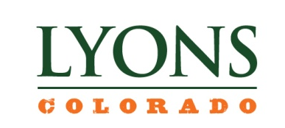
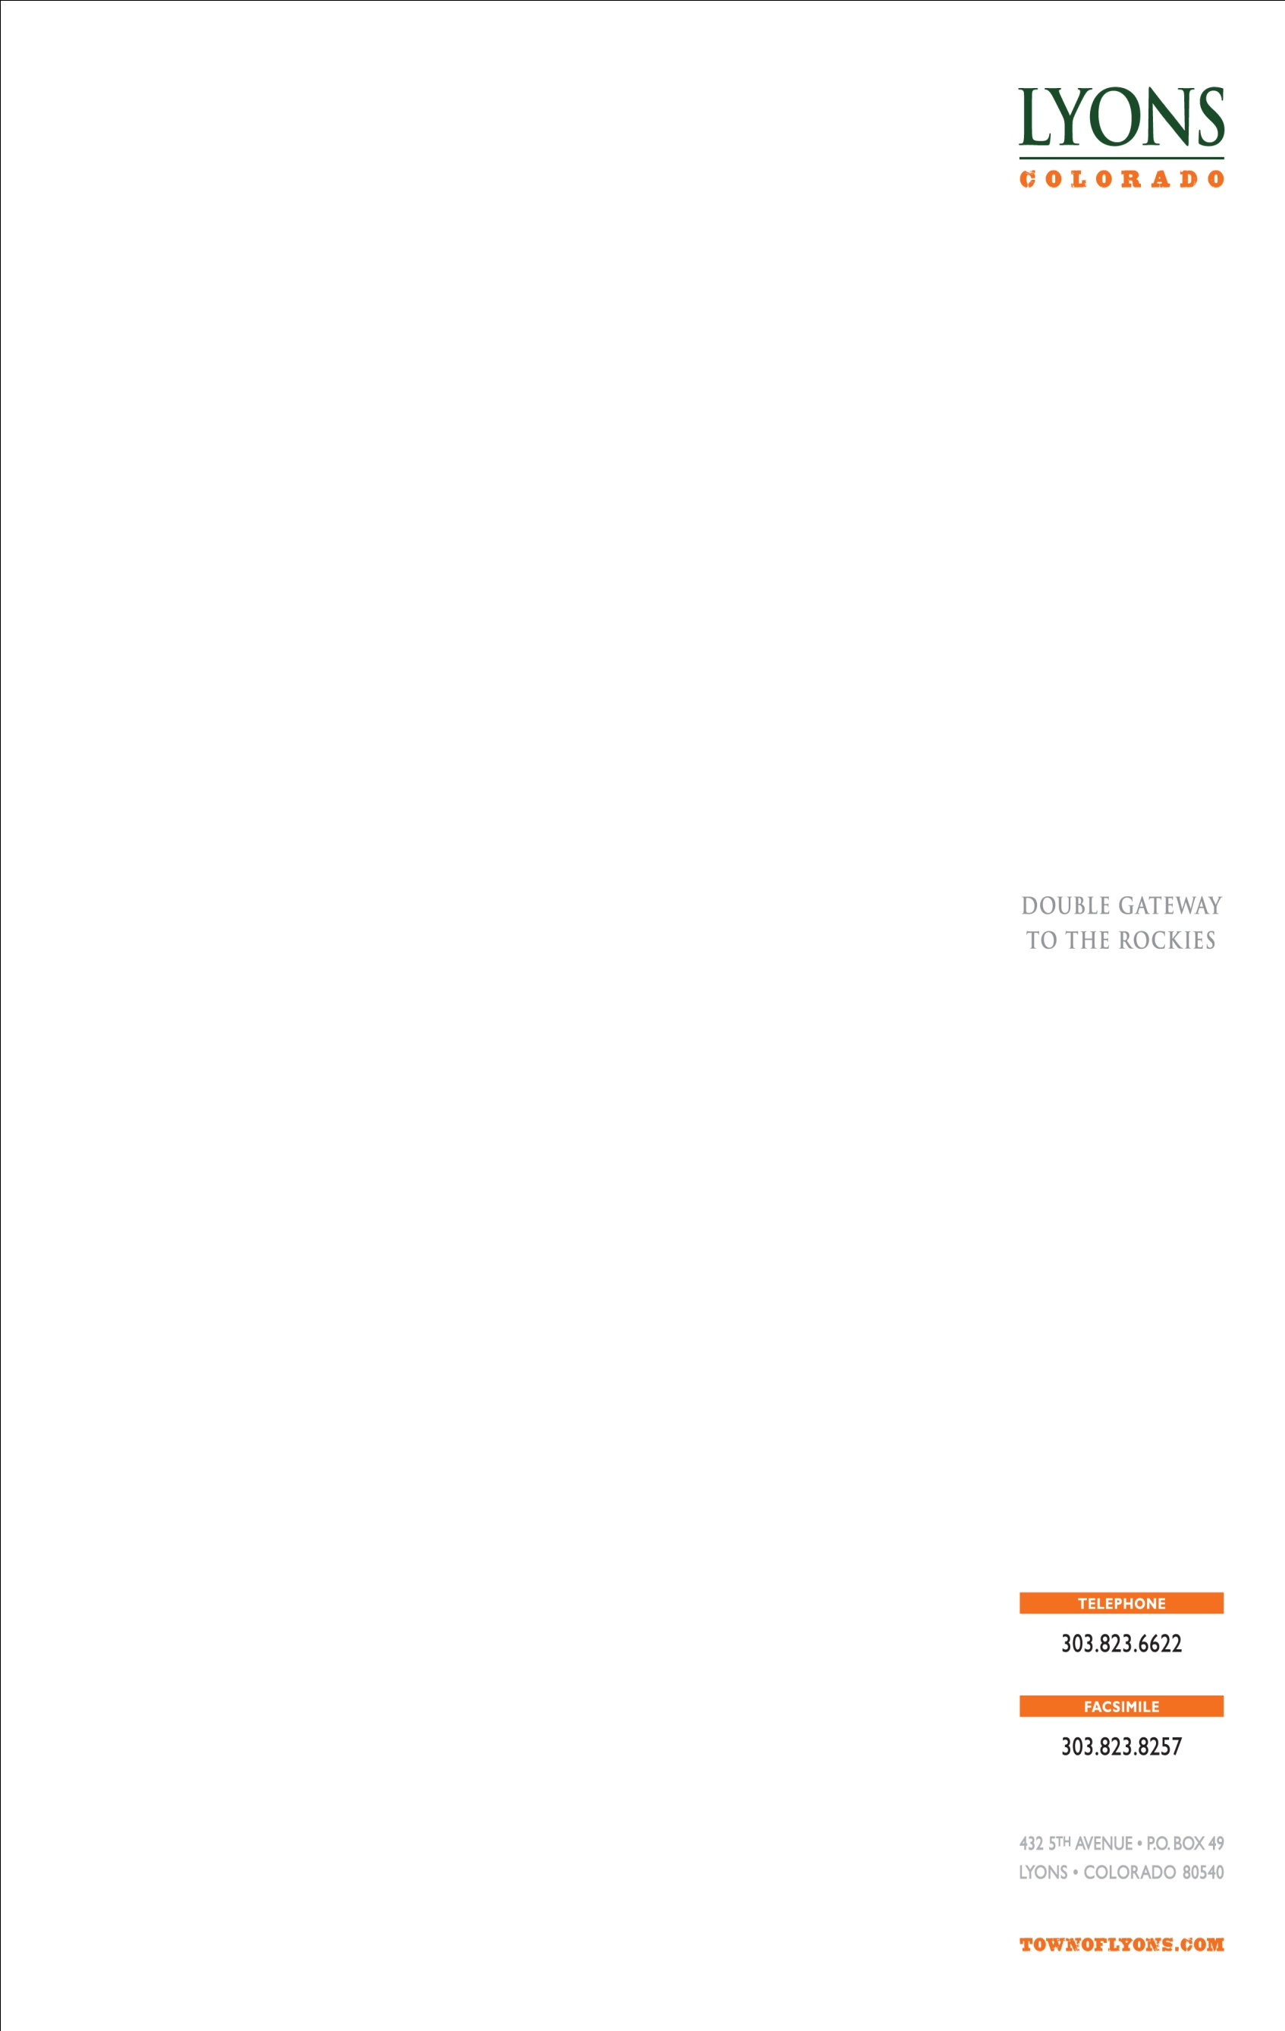
MARIJUANA BUSINESS LICENSE APPLICATION

NEW LICENSE TRANSFER OF OWNERSHIP LICENSE RENEWAL
RELOCATION ADD RECREATION TO EXISTING MEDICAL
Class Of License Sought: MARIJUANA CENTER CULTIVATION OPERATION
MARIJUANA-INFUSED PRODUCTS MANUFACTURING
TESTING, RESEARCH, AND DEVELOPMENT FACILITY
^{1.} | Applicant Name If an LLC, name of LLC; if partnership at least 2 partner’s names; if corporation, name of corporation
^{2a.} | ^{Name of Manager if applicable} |  |  | ^{Name of Owner} |  |  |  |  |  |  |  | ^{Fein Number}
^{2.} | ^{Trade Name of Establishment} |  |  |  |  |  | ^{State Sales Tax No.} |  |  |  | ^{Business Telephone}
^{3.} | Address of Premises (specify exact location of premises)
^{City} |  |  | ^{County} |  |  |  |  | ^{State} |  |  |  |  | ^{ZIP Code}
^{4.} | Mailing Address (Number and Street) |  | ^{City or Town} |  |  |  |  | ^{State} |  |  |  |  | ^{ZIP Code}
^{5.} | If the premises currently has an Medical Marijuana (MMJ) license, you MUST answer the following questions:
Trade Name of MMJ Establishment |  | ^{Town MMJ License Number} |  |  | ^{Class of MMJ License} |  |  |  |  | ^{MMJ License Expiration Date}
ALL ANSWERS MUST BE PRINTED IN INK OR TYPEWRITTEN
APPLICANT MUST CHECK THE APPROPRIATE BOX(ES)
LICENSE FEE $_______________
APPLICATION FEE $_______________
NONREFUNDABLE APPLICATION FEES |  |  | MJ OPERATING LICENSE FEES (a separate application is required for each license)
Application Fee for New License $1,000.00 |  |  | Medical Marijuana Center |  |  | $ 3,000.00 |  |  | Marijuana Center |  |  |  |  |  | $3,000.00
Application Fee for Transfer $ 1,000.00 |  |  | Testing Facility |  |  | $ 3,000.00 |  |  | Infused Products Manufacturer* |  |  |  |  |  | $3,000.00
Half of State Application fee ($2500) |  |  | Dual License |  |  | $3,000.00 |  |  | Cultivation Operation |  |  |  |  |  | $3,000.00
^{6.} | Has the Applicant knowingly made a false statement or knowingly given false information in connection with the application? |  |  |  |  |  |  |  |  |  |  |  |  | Yes |  | No | Not Appli-cable
^{7a.} | Is the (MMJ) Applicant prohibited by Section 12-43.3-307, C.R.S. from being a licensee?
^{7b.} | Is the (RMJ) Applicant prohibited by Section 12-43.4-306, C.R.S. from being a licensee?
^{8.} | Will the Applicant operate the Marijuana Business as a business prohibited by local or state law, statute, rule or regulation?
^{9.} | Has the Applicant had a Medical or Recreational Marijuana Business license or similar local or state license or approval revoked within the five (5) years before the date of the current application? |  |  |  |  |  |  |  |  |  |  |  |  | Yes |  | No | Not  Appli-cable
^{10.} | Is the proposed Marijuana Business a permitted use in the zone district in which the new site is located?
^{11.} | Is the proposed new location in the Commercial Eastern Corridor Zone District or General Industrial?
^{12.} | Is the proposed new location at least 1,000 feet from a public or private school, an alcohol or drug treatment facility, the principal campus of a college, university or seminary, public library, licensed daycare or a licensed residential care facility or another marijuana business?
^{13.} | Is the square footage of the proposed Retail Marijuana Store greater than 3,000 square feet?
^{14.} | Is the square footage of the proposed Retail Marijuana Cultivation Facility greater than 20,000 square feet? If the proposed facility is not a green house or will exceed 7,500 square feet, submit a feasibility study regarding the use of Town-owned utilities.
^{15.} | Is the square footage of the proposed Retail Marijuana Products Manufacturing facility greater than 7,500 square feet?
^{16.} | Does the Applicant currently hold a General Business License from the Town of Lyons?
^{17.} | If this is an application for renewal or transfer of an existing license, has the Applicant ceased operations for a period of 90 (ninety) days prior to seeking renewal or transfer?
^{18,} | HAS THE APPLICANT APPLIED FOR RELATED MARIJUANA BUSINESS FROM THE STATE OF COLORADO?  DATE SUBMITTED: _____________________ DATE RECEIVED:____________________  PLEASE PROVIDE TOWN STAFF WITH A COPY OF THE STATE LICENSE WHEN RECEIVED.

OATH OF APPLICANT

I declare under penalty of perjury in the second degree that this application and all attachments are true, correct, and complete to the best of my knowledge. I also acknowledge that it is my responsibility and responsibility of my agents and employees to comply with the provisions of the Town of Lyons Marijuana Business Ordinances which affect my license.
 | Authorized Signature | Title |  |  | Date
 | REPORT AND APPROVAL OF LOCAL LICENSING AUTHORITY (LLA)
 | Date application filed with Local Authority |  |  | Date of local authority hearing
 | THE LOCAL LICENSING AUTHORITY HEREBY AFFIRMS:  That each individual required to be listed on the license application has:  - Been fingerprinted and photographed by the Boulder County Sheriff’s Office  - Been subject to a local background investigation if determined by the LLA  - Consented to the Boulder County Sheriff’s Office for inspection of the proposed licensed  premise for the purpose of creating an environment that impedes criminal activity  Date of Inspection:_____________________________________________  - Results of the background investigation conducted through the Colorado Bureau of Investigation concerning the Applicant, owners, and registered managers for the Applicant, which investigation was completed on ______________ were satisfactory and in accordance with Ordinance 952.  - This completed application has been reviewed by the appropriate persons or agencies  upon which the LLA has reasonably determined should investigate and comment |  |  |  |  |  | Yes | No
The foregoing application has been examined; and the premises, business to be conducted and character of the applicant are satisfactory. We do report that such license, if granted, meets the approval criteria set forth in LMC 2-6 and in Sections 12-43.4-301, and 12-43.3-101et seq., C.R.S., also known as the Colorado Retail Marijuana Code and the Colorado Medical Marijuana Code.

THEREFORE THIS APPLICATION IS APPROVED BY THE TOWN OF LYONS LOCAL LICENSING AUTHORITY.
 | ^{Signature} |  | ^{Title} |  |  | ^{Date}
 | ^{Signature (attest)} |  | ^{Title} |  |  | ^{Date}

TOWN OF LYONS MARIJUANA BUSINESS LICENSE
APPLICATION DOCUMENTS CHECKLIST AND WORKSHEET

 |  | Instructions: This checklist should be used to assist applicants with filing all required documents for licensure. All documents must be properly signed and correspond with the name of the applicant exactly. All documents must be typed or legibly printed. Upon final Town approval the license will be mailed to the State Licensing Authority. Application fees are nonrefundable.
ITEMS SUBMITTED, PLEASE CHECK ALL APPROPRIATE BOXES COMPLETED OR DOCUMENTS SUBMITTED
I. |  |  |  |  | APPLICANT INFORMATION
 |  |  | A. | Applicant/Licensee Identified and manager listed
 |  |  | B. | State sales tax license listed or applied for
 |  |  | C. | License type or other transaction identified
 |  |  | D. | Return originals to Local Licensing Authority
II. |  |  |  | DIAGRAM OF THE PREMISES
 |  |  | A. | No larger than 8 ½” X 11”.
 |  |  | B. | Dimensions included (doesn’t have to be to scale). Exterior areas should show control (fences, walls, etc.) Square footage of premise:___________
 |  |  | C. | Separate diagram for each floor
 |  |  | D.  E.  F. | Kitchen – identified if Retail Marijuana Products Manufacturing facility  Description of Proposed construction (include site plan and architect’s drawing as well as interior sketch  Neighborhood Feasibility Study (for qualifying cultivation operations.
III. |  |  |  | PROOF OF PROPERTY POSSESSION
 |  |  | A. | Deed in name of Applicant only (or)
 |  |  | B. | Lease in name of Applicant only
 |  |  | C. | Lease Assignment in the name of the Applicant only with proper consent from the Landlord and acceptance from the Applicant
 |  |  | D. | Other Agreement if not deed or lease
IV. |  |  |  | WAIVERS and ACKNOWLEDGEMENTS
 |  |  | A.  B. | A statement signed by the applicant acknowledging that the Town accepts no legal liability in connection with the approval and subsequent operation of the Marijuana Business.  Acknowledgement that Town will rely on the findings of the Colorado Department of Revenue regarding all mandatory background investigations and will conduct only a limited background investigation of its own.
V. |  |  |  | NEIGHBORHOOD RESPONSIBILITY PLAN
 |  |  |  | A document that outlines the applicant’s plans for outreach and communication with neighbors
VI. |  |  |  | BACKGROUND AND SECURTY INFORMATION
 |  |  | A. | Fingerprints taken
 |  |  | B. | Photograph taken by Boulder County Sheriff’s Office
 |  |  | C. | Background investigation by Boulder County Sherriff’s Office, if deemed necessary by LLA
 |  |  | D. | Exterior inspection of proposed premises by Boulder County Sheriff’s Office if deemed necessary by LLA
VII. |  |  |  | ANY ADDITIONAL INFORMATION DEEMED NECESSARY BY THE LOCAL LICENSING AUTHORITY

