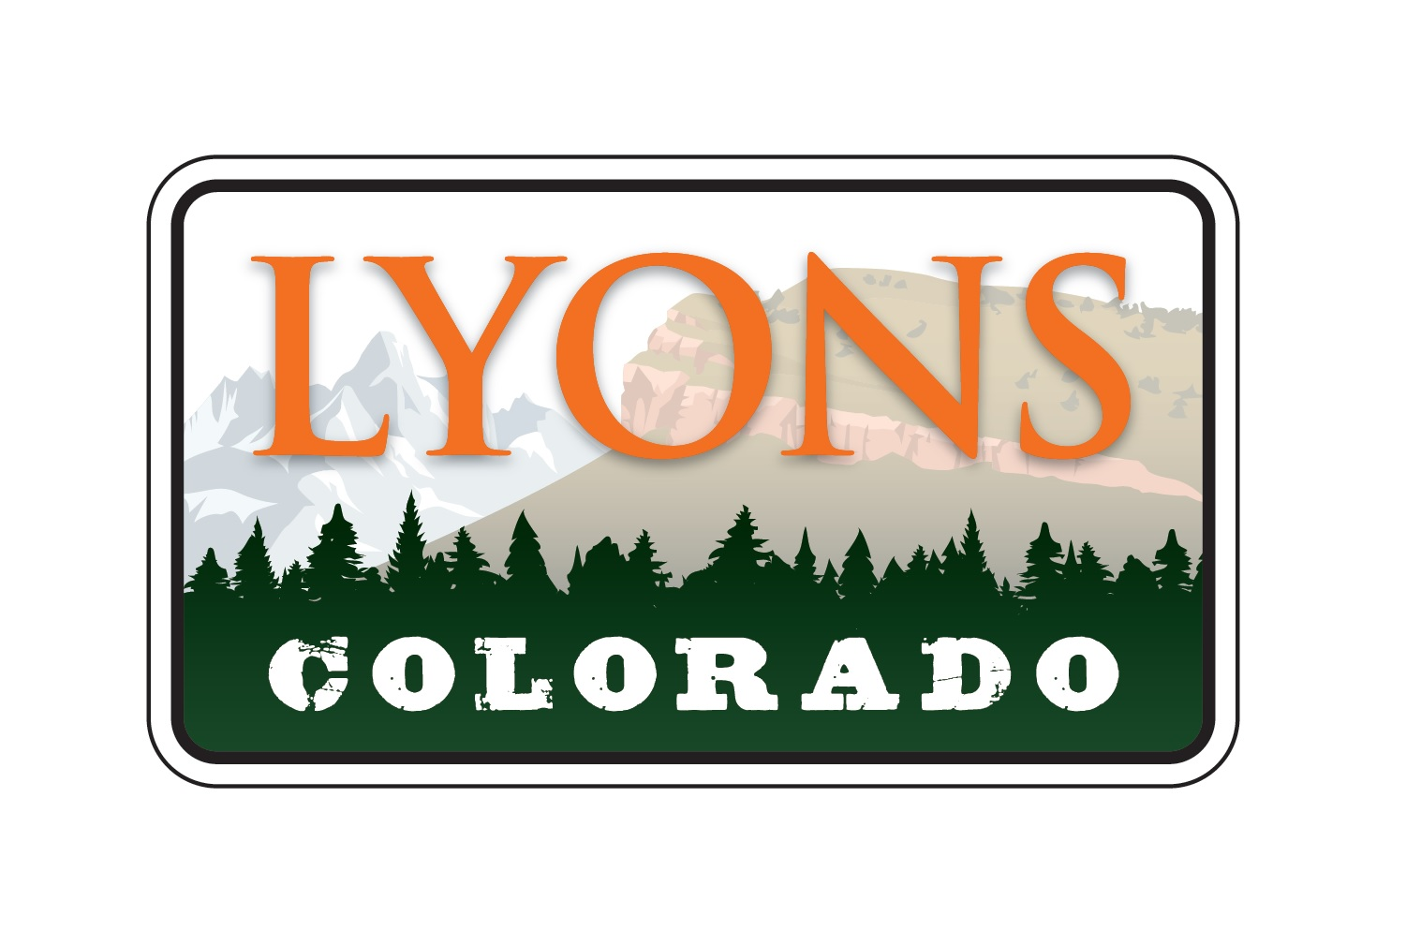

June 21, 2022

PUBLIC MEETING NOTICE

Notice is hereby given that the Town of Lyons Board of Trustees will meet at 6:00 pm., on Thursday, June 23, 2022, at Modis located at 113 S. Main St., Breckenridge, CO 80424 to attend CML Conference and dinner.

Dolores Vasquez, CMC
Town Clerk
Town of Lyons

