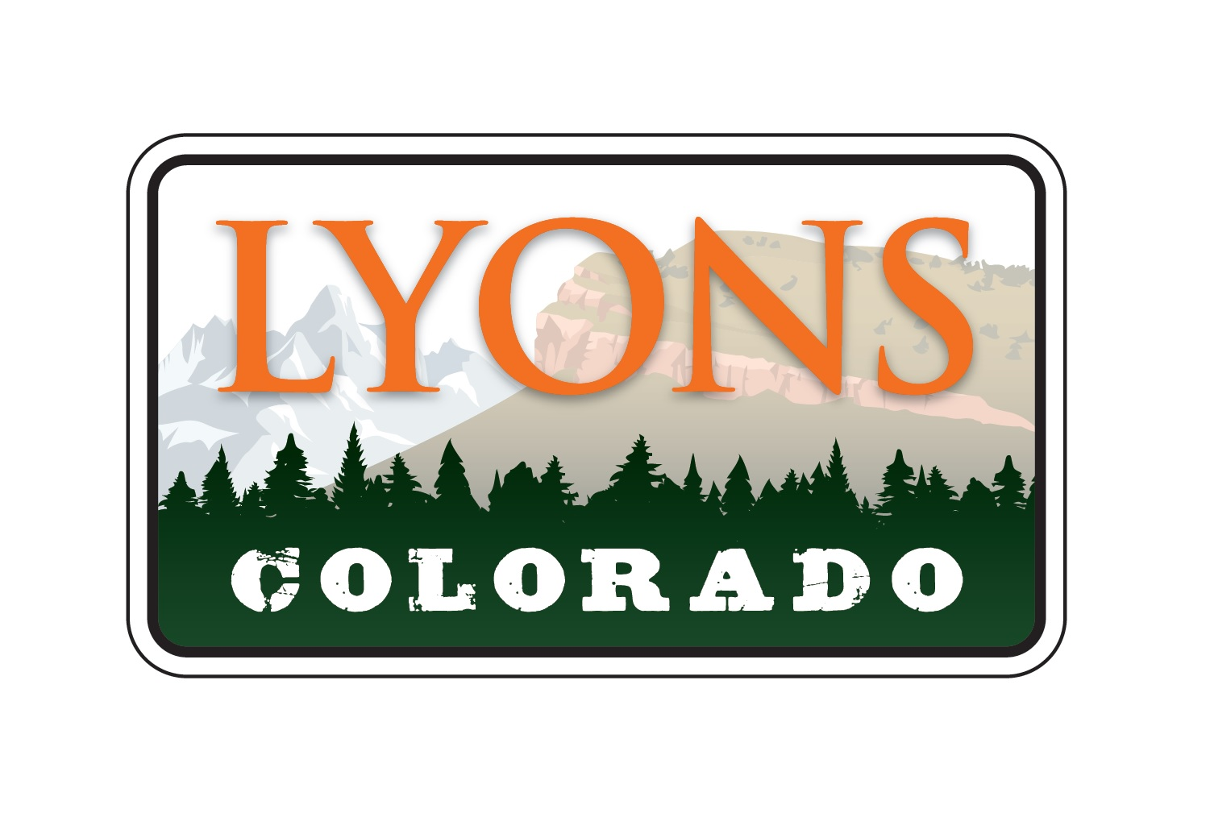

June 16, 2022

PUBLIC NOTICE

Notice is hereby given members of the Town of Lyons Board of Trustees will be attending the Juneteenth Flag Raising Ceremony Friday, June 17, 2022 at 9:00 am at the Town of Lyons Marquee at the intersection of Main and 3rd Street, Lyons, CO.

Submitted by:

Dolores Vasquez, CMC
Town Clerk
Town of Lyons

