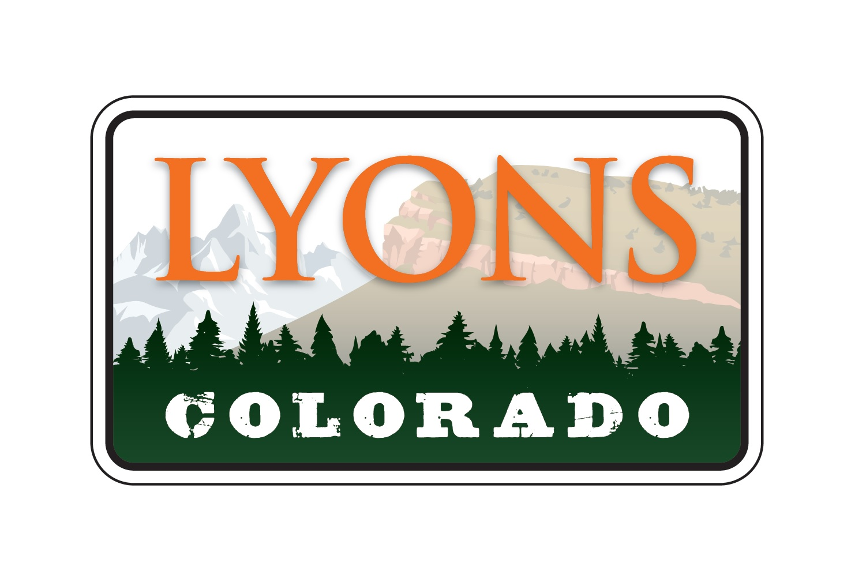

June 14, 2022

PUBLIC NOTICE

Notice is hereby given members of the Town of Lyons Board of Trustees will be attending the Comprehensive Plan Updated presented by Clarion on June 16, 2022 from 7:00 pm – 9:00 pm at the Lyons Regional Library, 451 4th Avenue, Lyons, CO.

Submitted by:

Dolores Vasquez, CMC
Town Clerk
Town of Lyons

