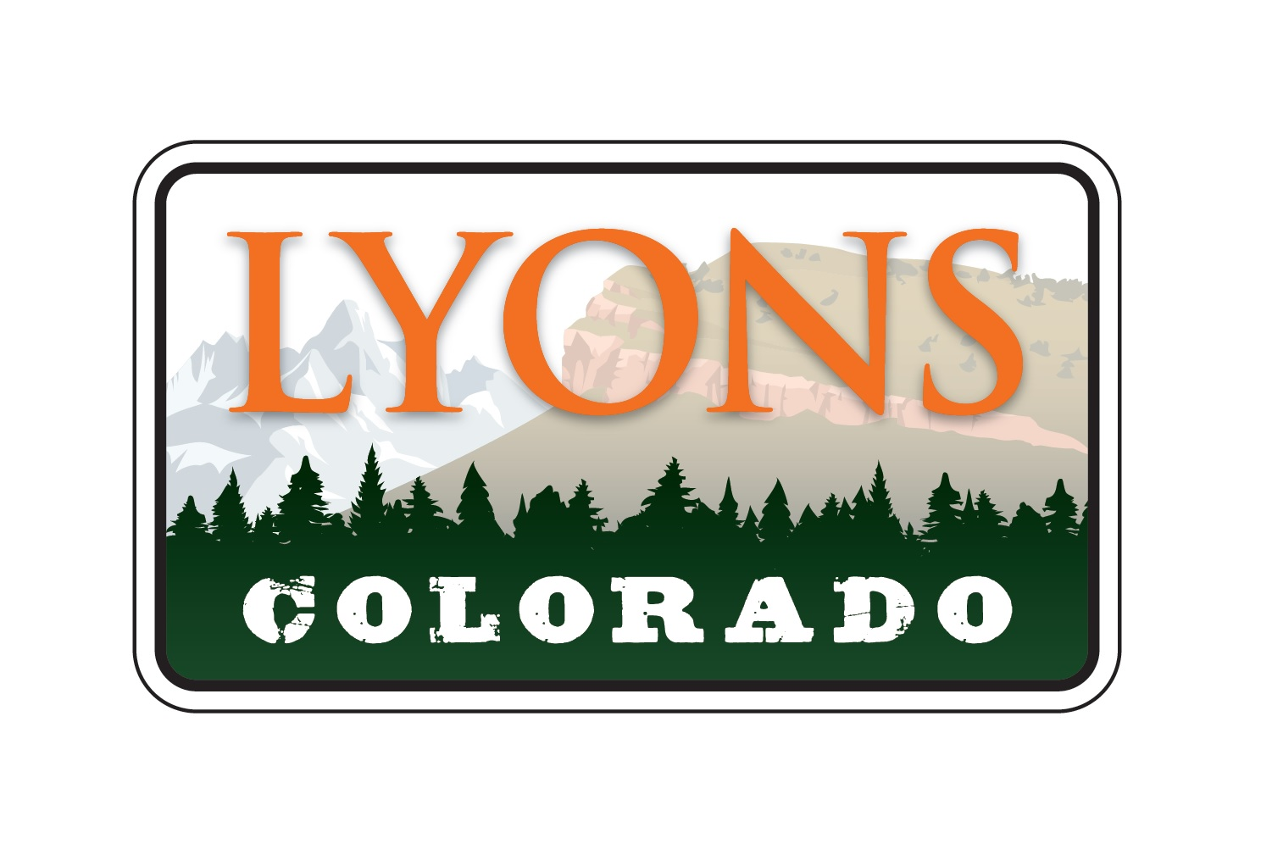

June 14, 2022

PUBLIC NOTICE

Notice is hereby given members of the Town of Lyons Board of Trustees will be attending the Boulder County Commissioners Town Hall on Thursday, June 16, 2022 from 5:30 pm – 7:00 pm at the Lyons Fire Protection District, 251 Broadway, Lyons, CO.

Submitted by:

Dolores Vasquez, CMC
Town Clerk
Town of Lyons

